Workshop Delivery Guidance

Business Intelligence

Abstract:

This document describes a Workshop for creating a customer customized Reference Model and Reference Architecture Models in the Business Intelligence Domain. The Workshop flow and deliverables are aligned to VRF 2.0 as closely as possible.

Author:

David Meltzer

Mike Wise – IP Architect

Susan Conway – IP Architect

Editors:

<Name>

Publication Date:

March 2012

Version:

1.0

We welcome your feedback. Please send your comments to the Microsoft Services Enterprise Architecture IP team at [*ipfeedback@microsoft.com*](mailto:ipfeedback@microsoft.com?subject=Feedback%20on%20the%20Business%20View%20for%20Business%20Intelligence%20Solutions).

Document Readership

<placeholder>

Acknowledgements

<placeholder>

© 2012 Microsoft Corporation. All rights reserved. This document is provided "as-is." Information and views expressed in this document, including URL and other Internet Web site references, may change without notice. You bear the risk of using it.

This document does not provide you with any legal rights to any intellectual property in any Microsoft product. You may copy and use this document for your internal, reference purposes. This document is confidential and proprietary to Microsoft. It is disclosed and can be used only pursuant to a non-disclosure agreement.

Table of Contents

1 Introduction 4

2 Prerequisites 5

3 VRF and the BI Workshop 6

3.1 Assessment 6

3.2 Initiative Planning 6

4 Workshop Output 7

5 Workshop Structure 8

5.1.1 Deliverable Creation Process 8

5.2 Team Handoffs 8

6 Module Content 10

6.1 Module 1 – Identify Business Drivers, Enterprise Personas and Scenarios 10

6.1.1 Team 10

6.1.2 Deliverables 10

6.1.2.1 Business Drivers 10

6.1.2.2 Enterprise Personas and Scenarios 10

6.1.3 Supporting Material 10

6.1.4 Module Activities 11

6.2 Module 2 – Identify Capability Gaps & Engagement Opportunities 12

A capability assessment is made for the customer in this step. The VRF 2.0 Assessment Workbook can be used for this task. 12

6.2.1 Team 12

6.2.2 Deliverables 12

6.2.2.1 Business Capabilities 12

6.2.2.2 People Capabilities 12

6.2.2.3 Technology Capabilities 12

6.2.2.4 Capabilities Diagnostic 12

6.2.2.5 Engagement Opportunities 12

- Create / Enhance an Operational Business Intelligence Platform 13

- Create / Enhance an Strategic Business Intelligence Platform 13

- Create / Enhance an Self-service BI Presentation Platform 13

6.2.3 Supporting Material 13

6.2.4 Module Activities 13

6.3 Module 3 – Create Customized Reference Model 14

6.3.1 Team 14

6.3.2 Deliverables 14

6.3.3 Supporting Material 14

6.3.4 Module Activities 14

6.4 Module 4 – Create Conceptual Business Model 15

6.4.1 Team 15

6.4.2 Deliverables 15

6.4.3 Supporting Material 15

6.4.4 Module Activities 15

6.5 Module 5 – Create Conceptual Information Models 16

6.5.1 Team 16

6.5.2 Deliverables 16

6.5.3 Supporting Material 16

6.5.4 Module Activities 16

6.6 Module 6 – Create Conceptual Technology Model 17

6.6.1 Team 17

6.6.2 Deliverables 17

6.6.3 Supporting Material 17

6.6.4 Module Activities 17

6.7 Module 7 - Review Customized Reference Architecture 18

6.7.1 Team 18

6.7.2 Deliverables 18

6.7.3 Supporting Material 18

6.7.4 Module Activities 18

7 References 19

8 Appendix A: The World of BI 20

8.1 Defining Business Intelligence Solutions 20

8.1.1 Business Intelligence Classification Framework 20

8.1.1.1 Operational Business Intelligence 22

8.1.1.2 Strategic Business Intelligence 22

8.2 Business Value Proposition 22

8.3 Drivers 24

9 Appendix B: Functional and Nonfunctional Requirements for BI solutions 27

9.1 Details of Common Functional Requirements 27

9.2 Details of Common Nonfunctional Requirements 30

9.3 Aligning Requirements to the BI Business Conceptual Model 36

10 Appendix C: Customizable BI Reference Model 38

11 Appendix D: Value Propositions 45

11.1 Information View Value Proposition 45

12 Appendix E: One-Page Introduction to Workshop for Customers 46

# Introduction

The Microsoft Services Enterprise Strategy mission is to help customers and partners realize their full potential by utilizing the skills, experience, and oversight of a Microsoft Enterprise Architect to accelerate adoption and productive use of Microsoft technologies. The Value Realization Framework (VRF) is the structure for this process.

This Supplemental Delivery Guide (SDG) document, a Microsoft internal document, is a part of the *Business Intelligence VRF Accelerator*. This guide is intended for use by Microsoft Enterprise Architects (EAs) and service delivery teamsperforming *Assessment Workshop* activities within the VRF 360 Assessment segment. As a supplementary delivery guide, it describes how a *Business Intelligence* Assessment Workshop complements and extends the 360 Assessment Delivery Guide.

This guide can help the EA position the material from the *Business Intelligence* Accelerator to formulate an Assessment Workshop for Business Intelligence (AWBI) within the second phase (Assess) of the first segment (Assessment) of the VRF. The SDG is for guidance only, and is not intended to restrict the EA from using the AWBI content in other workshop delivery opportunities.

The generalized version of the AWBI is a two to five day workshop (with the days six-to-eight hours in length), ideally delivered on Microsoft property with access to the Microsoft corporate network. The EA can expand the AWBI into a multi-day workshop by allotting more time for the group discussion and assessment work sessions. The EA can modify or eliminate certain components of the AWBI to better support an effective workshop delivery on the customer’s site. Normally, the AWBI is presented by a “delivery team” consisting of an Enterprise Architect and other members assigned by the EA, to a customer team consisting of business decision-makers (BDMs) and technical decision-makers (TDMs).

# Prerequisites

This guide does not repeat general content delivered within the introductory VRF documentation. In addition, knowledge of the contents of the BI Reference Architecture is considered a prerequisite for delivering this workshop. The EA should have reviewed the following documents:

VRF-Related Content

* **VRF Delivery Guide for BI** – This is a delivery guide for VRF that is focused on how the BI Reference Architecture can be used to support a VRF engagement end-to-end.
* **VRF Assessment Workbook** (VRF_Assessment_Workbook.xls) – This is a spreadsheet that should be maintained by all EAs for their customers. It contains details on the models as they are instantiated at a customer.

BI-Related Content

* “Big Data” Point-of-View Whitepaper
* Business Intelligence Reference Architecture Solution Package, including:
  + Reference Model
  + Overview
  + Business View
  + Information Management View
  + Information Application View
  + Technology View
  + Visio files containing model templates

# VRF and the BI Workshop

## Assessment

This workshop helps to identify topics and models within the **Context**, **Validation** and Prioritize phases of the Assessment segment of the VRF.



Specifically these are:

1. **Customer Pain Points** and **Business Drivers**
   1. Identify pain points
   2. Identify additional business drivers and value drivers
2. **Enterprise Personas** and **Scenarios**
   1. Identify the enterprise personas of importance to the customer
   2. Identify the enterprise scenarios of importance to the customer
3. **Capability Diagnostic**
   1. Identify current customer business, technical and personal capabilities
   2. Identify target capabilities for customer and capability gaps
4. **Engagement Opportunities**
   1. Summarize Microsoft offerings that can enable recommendations for improvements.
   2. Identify possible engagement opportunities.

## Initiative Planning

The workshop also supports the **Initiative Planning** segment of the VRF in all phases.



The following deliverables inform the **Architecture Definition Delivery** document which is a central deliverable in the Initiative Planning phase:

1. **Customized Reference Model** – creates the context and defines the entities in which the various other models will be formulated.
2. **Conceptual Business Model**- Supports business decisions and enables a prioritization of engagement opportunities. Specifically it informs the *Current State Business Architecture* section and the *Future State Business Architecture* sections of the **Architecture Definition Delivery** document.
3. **Conceptual Information Model** – Frames the information flows to enable a technology neutral view of technical requirements. Specifically it informs the *Current State Information Architecture* section and the *Future State Information Architecture* sections of the **Architecture Definition Delivery** document.
4. **Conceptual Information Application Model** - – Frames the information flows to enable a technology neutral view of technical requirements. Specifically it informs the *Current State Application Architecture* section and the *Future State Application Architecture* sections of the **Architecture Definition Delivery** document.
5. **Conceptual Technology Model –** Embodies a formulation of the technical requirements in a technology agnostic way, which can be used to compare differing technical implementations. Specifically it informs the *Current State Technology Architecture* section and the *Future State Technology Architecture* sections of the **Architecture Definition Delivery** document.

# Workshop Output

During this workshop the EA will create the following deliverables.

* Customer Context
  + Business Drivers and Pain points
  + Enterprise Scenarios
  + Personas
  + Business Capabilities
  + Technical Capabilities
  + Personal Capabilities
  + Capability Gaps
  + Engagement Opportunities
* Customized Reference Model
* Conceptual Business Model
* Conceptual Information Model
* Conceptual Information Application Model
* Conceptual Technology Model

# Workshop Structure

The Workshop is structured into 7 Modules as follows



The first two modules can potentially build on previous work done by the EA as part of the Assessment Phase. Alternately these two modules can be informed with standard VRF delivery material, for example the VRF Accelerators or the VRF 2.0 Reference Guide.

### Deliverable Creation Process

The deliverable creation process consists of the following:

1. Microsoft Team presents a generic version of deliverable
2. Module Team modifies it to fit customer situation and context creating a “Draft Version”
3. Microsoft Team creates a finalized version of the deliverable for review in the next module.
4. Microsoft Team adjusts finalized version of the previous deliverable incorporating feedback from the Validation Review.

## Team Handoffs

Versions deliverables are created by a set of teams in a “handoff” fashion, whereby one team validates the output of the next team. This works best if the composition of the various teams varies with every module, thereby introducing more points-of-view and ensuring that the deliverables will have a higher overall quality. The “Handoff” process also ensure continuity (since each team reviews one deliverable and creates the next)

The overall flow is illustrated in the following diagram:



# Module Content

The seven modules consist of the following content.

## Module 1 – Identify Business Drivers, Enterprise Personas and Scenarios

This phase is the opening part of the workshop. It can last between 1 hour and 4 hours depending on the amount of material that is delivered and the time that is available.

These will be needed to drive the creation of the other artifacts in the later modules.

### Team

The team should be complete if possible, but in any case a business focused team – ideally consisting of:

* Microsoft Enterprise Architect
* Microsoft BI SMEs
* Customer Corporate Sponsor
* Customer Business Analysts
* Customer BI SMEs

### Deliverables

The output should be at a minimum the following:

* List of Customer BI Business Drivers
* List of Customer BI Scenarios

#### Business Drivers

The business drivers are defined in the VRF 2.0 Object Model and should be tracked in the **VRF Assessment Workbook** under the tab “**Business Drivers**”.

Sample business drivers that are relevant for BI can be found in this document under **Appendix A: The World of BI** under the section **Drivers**.

Additional material around drivers from the BIRA can be found in:

* **BIRA Business View – Section 2.2 - Business Intelligence Business Drivers**
* **BIRA Business View – Chapter 3 - Value Proposition**

#### Enterprise Personas and Scenarios

BI Personas are discussed in detail in the BIRA. In particular see:

* **BIRA Business View – Section 2.1 - Business Intelligence Persona and Roles**
* **BIRA Business View – Appendix A – Description of Business View Personas**

### Supporting Material

* VRF Delivery Guide for the BI Reference Architecture.
* Reference Architecture Business View for Business Intelligence Solutions.
* Bart and Marc’s Persona Toolkit

### Module Activities

The following actives are foreseen in this step.

1. Formalities - Introduction and Agenda
2. Optionally: Present “The World of BI” content in Appendix A with at Short Q&A Session.
3. Optionally: Present the “Big Data” Point-of-View (separate document) with a short Q&A session.
4. Discuss and agree upon enterprise pain-points and BI concerns.
5. Create draft enterprise personas using the material found in the BI Reference Architecture.
6. Create draft enterprise scenarios using material found in the VRF Delivery Guide for BI.
7. **Post Module**: The EA and his SME team completes final versions of deliverables

## Module 2 – Identify Capability Gaps & Engagement Opportunities

### A capability assessment is made for the customer in this step. The VRF 2.0 Assessment Workbook can be used for this task.

### Team

The team should be a balanced team able to deal with both technology and business components. An example team would be:

* Microsoft Enterprise Architect
* Microsoft BI SMEs
* Customer Business Analysts
* Customer BI SMEs

### Deliverables

The minimum set of deliverable for this activity should be a set of business, people and technology capabilities, with the current maturity levels, desired future maturity levels, and gaps. This gap analysis can be used in the prioritize phase of the Assessment Segment to help determine which opportunities will be pursued.

#### Business Capabilities

Business capabilities should be drawn from the tab of the same name in the VRF Assessment Workbook. There are several models tracked simultaneously in that tab, a single one (preferably the APQC Cross Industry) should be selected.

#### People Capabilities

People capabilities should be drawn from the tab of the same name in the VRF Assessment Workbook.

#### Technology Capabilities

A relevant technology capability model can be found in Appendix C.

#### Capabilities Diagnostic

A capability diagnostic shows the gaps between the current and the future desired maturity levels. This can be used to prioritize the engagement opportunities previously identified (for example in the previous module). This will usually be an assessment in the form of a spreadsheet. These gaps should also be tracked in the **VRF Assessment Workbook**.

#### Engagement Opportunities

A preliminary set of engagement Opportunities that could alleviate the gaps identified in the previous step should be identified here. At this stage the budget or technical feasibly is not the focus, rather these are used to help define the solution space models that will be developed in the subsequent models.

Engagement Opportunities can be informed by section 3.3 of the Business View of the BIRA, “Overview of BI Solutions”. One possible set of engagement opportunities could be:

#### Create / Enhance an Operational Business Intelligence Platform

#### Create / Enhance an Strategic Business Intelligence Platform

#### Create / Enhance an Self-service BI Presentation Platform

* Create / Enhance a BI Data Management Platform

Although in general these will be customer specific.

### Supporting Material

* VRF Delivery Guide for the BI Reference Architecture.
* Reference Architecture Business View for Business Intelligence Solutions.
* VRF Assessment Workbook.
* Appendix C: Customizable BI Reference Model

### Module Activities

The module has the following activities:

1. Selection and presentation of appropriate Business Capability model. This will usually be either the APQC Cross Industry or the MSBA model, though other customer specific models may be substituted.   
   Since some of the capability models are very large a subset may need to be selected.
2. For each important capability a current and a future capability maturity level should be assessed.
3. The same process should be applied to the Personal and the Technical Capabilities.
4. A capability diagnostic assessment should be produced as the final result of this module.
5. A set of engagement opportunities that could close the gaps identified in the previous step should be identified in this step.
6. **Post Module**: The EA and his SME team complete final versions of deliverables

## Module 3 – Create Customized Reference Model

### Team

The team should be a balanced team able to deal with both technology and business components. An example team would be:

* Microsoft Enterprise Architect
* Microsoft BI SMEs
* Customer Business Analysts
* Customer BI SMEs

### Deliverables

The deliverable for this module is a customer customized BI Reference Model. This BIRA reference model needs to show and describe the following capabilities and entities:

* BI Analytics
* BI Reporting
* BI Data Source
* Information Management
* Information Infrastructure
* Information Repository

A reference model should be created that described the domain in Microsoft BI Reference Architecture compatible terms that the customer can identify with.

A reference model should contain a list of all the important BI entities in a

### Supporting Material

* BI Reference Architecture Reference Model
* Reference Architecture Business View for Business Intelligence Solutions
* Appendix C: Customizable BI Reference Model

### Module Activities

1. Validate deliverables from previous module
2. Generic Reference Model Presented
3. Module team creates draft Reference Model
4. **Post Module**: The EA and SME team complete final versions of Reference Model
5. **Post Module**: The EA and SME team incorporates feedback into deliverables from previous module.

## Module 4 – Create Conceptual Business Model

This is the one of the main business discussion phases of the AWBI and spans between three-to-five hours. This can also expand into multi-day sessions, depending on the audience, level, depth, and goals of the workshop.

### Team

The team should be a business focused team – at a minimum consisting of:

* Microsoft Enterprise Architect
* Customer Business Analysts

### Deliverables

The deliverables for this module are the following:

* Customized Conceptual Business Model.
* Optionally: One or more customized Benefits Dependency Network (BDN) Diagrams.

### Supporting Material

* Reference Architecture Business View for Business Intelligence Solutions

### Module Activities

The EA will orchestrate the overall flow. As a general guideline, the following steps occur:

1. Validate the Reference Model created in the previous module.
2. Module team presents the Benefits Assessment Customer Introduction
3. Review content from Modules 1 and 2 so as to focus the customer on the business relevant drivers, personas, and scenarios.
4. *Optional –* Module team create a customer tailored BDN together.
5. Delivery Team facilitates group discussions or team breakout sessions, as appropriate
6. Draft Customized Business Model is created using the information in the BIRA Business View.
7. **Post Module**: The EA and SME team complete final versions of Conceptual Business Model
8. **Post Module**: The EA and SME team incorporates validation feedback into Reference Model from previous module.

## Module 5 – Create Conceptual Information Models

### Team

The team should be a more technically focused team – ideally consisting of:

* Microsoft Enterprise Architect
* Microsoft BI SMEs
* Customer BI SMEs

### Deliverables

The deliverables for this module are the following:

* Customized Conceptual Information Model
* Customized Conceptual Information Application Model

### Supporting Material

* Reference Architecture Information View for Business Intelligence Solutions

### Module Activities

1. Validate the Business Model created in the previous step.
2. Discuss info flow, management, storage, requirements, backend.
3. Review the Engagement Opportunities from Module 1 to ensure we have a complete understanding of the solution space we are going to delineate.
4. Review Technical Capability capabilities and gaps established in Module 2 to enhance our complete understanding of the solution space we are going to delineate.
5. Create the Information Model using material from the BIRA Information View
6. Explore questions needed to shape the information application model.
7. Create the Information Application Model using material from the BIRA Information View.
8. **Post Module**: The EA and SME team complete final versions of Conceptual Information Models
9. **Post Module**: The EA and SME team incorporates validation feedback into Conceptual Business Model from previous module.

## Module 6 – Create Conceptual Technology Model

### Team

The team should be a more technically focused team – ideally consisting of:

* Microsoft Enterprise Architect
* Microsoft BI SMEs
* Customer BI SMEs

### Deliverables

The deliverables for this module are the following:

* Customized Conceptual Technology Model

### Supporting Material

* Reference Architecture Technology View for Business Intelligence Solutions

### Module Activities

1. Validate the Information Models created in the previous step.
2. Review the Engagement Opportunities from Module 1 to ensure we have a complete understanding of the solution space we are going to delineate.
3. Review Technical Capability capabilities and gaps established in Module 2 to enhance our complete understanding of the solution space we are going to delineate.
4. Create the Technical Model using material from the BIRA Technology View.
5. **Post Module**: The EA and SME team complete final versions of Conceptual Technology Models
6. **Post Module**: The EA and SME team incorporates validation feedback into Conceptual Information Models from previous module.

## Module 7 - Review Customized Reference Architecture

### Team

The team should be complete if possible, but in any case a business focused team – ideally consisting of:

* Microsoft Enterprise Architect
* Microsoft BI SMEs
* Customer Corporate Sponsor
* Customer Business Analysts
* Customer BI SMEs

### Deliverables

There are no new deliverables in this phase, but rather all the deliverables should be looked over and compared holistically to ensure consistency and that the overall message and direction is correct.

### Supporting Material

There is no new supporting material for this step.

### Module Activities

1. Review and Validate the Business Drivers, Personas and Scenarios developed in Module 1
2. Review and Validate Capability Gaps and Engagement Opportunities developed in Module 2.
3. Review and Validate Reference Model developed in Module 3.
4. Review and Validate Conceptual Business Model developed in Module 4.
5. Review and Validate Conceptual Information Models developed in Module 5.
6. Review and Validate Conceptual Technical Model developed in Module 6.
7. **Post Module**: The EA and SME team complete final versions of all deliverables incorporating feedback from this module.
8. **Post Module**: Deliverables formally presented to customer as Workshop result.

# References

The Enterprise Strategy Program Library. <http://sharepoint/sites/enterprisestrategyprogram/Pages/Welcome.aspx>

Enterprise Strategy Program Overview. <http://sharepoint/sites/enterprisestrategyprogram/_layouts/PowerPoint.aspx?PowerPointView=ReadingView&PresentationId=/sites/enterprisestrategyprogram/PresentationsCollateral/Internal%20Use%20Decks/ES%20Program%20Overview%20093010%202359.pptx>

Microsoft EPG sites – **Solutions Alignment Workshop** (SAW) & **Detailed Discovery Workshop (**DDW) at <https://spsites.microsoft.com/sites/bosm/boswiki/Pages/default.aspx>

Microsoft Global Foundation Services (GFS)

* <http://ignition>
* [Latest Data Farm articles](http://www.datacenterknowledge.com/archives/2011/01/04/microsofts-high-tech-modular-tractor-shed/)

# Appendix A: The World of BI

The following content is excerpted from the Business Intelligence Reference Architecture. The location of this content is changing.

## Defining Business Intelligence Solutions

BI has become a necessary and critical component for the success of most enterprises, regardless of industry. To remain competitive in a dynamic landscape, organizations require capabilities provided by BI solutions, especially timely access to information and analysis. Using a BI solution, decision makers at all levels of an organization can obtain strategic insight and collaborate in accessing, understanding, and analyzing information.

BI is a set of methodologies, architectures, processes, applications, tools, and other resources. A BI solution obtains data stored in an organization’s business systems, transforms the data into meaningful and useful information, and delivers the information to support information/knowledge workers and business decision makers who make strategic, tactical, and operational decisions. BI architectures need to be flexible and scalable to accommodate the dynamic requirements of businesses. BI solutions often also integrate public or external information in order to enrich and expand the BI analytics.

BI encompasses many technology disciplines, including data integration, data quality, data warehousing, analysis, master data management, and information delivery. The BI domain extends far beyond corporate performance reporting: BI is extremely valuable for enabling fact-based strategic decisions, reducing costs, increasing revenues, and identifying new business opportunities.

### Business Intelligence Classification Framework

The BI Classification Framework describes the characteristics of different types of BI solutions, and provides a context for distinguishing between operational and strategic solutions. The framework associates two types of BI to the data and reporting requirements of the BI type: Operational (tactical) and Strategic (analytical/predictive).

The framework is useful for clarifying the different types and frequency of data sourcing, the demands of Operational and Strategic BI, and the differences in the data specificity and output cycle that is associated with each type of data sourcing. The following figure illustrates the framework.

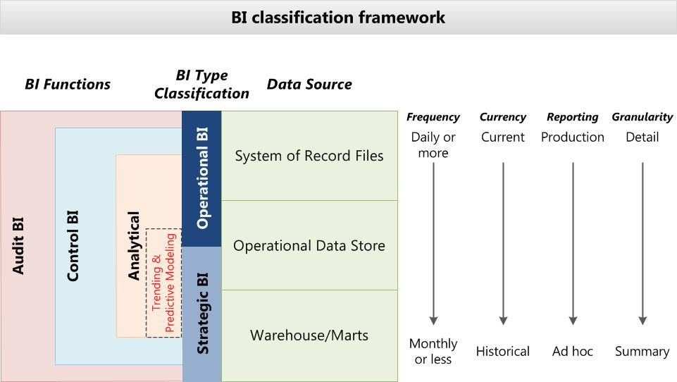

Figure : BI classification framework

The Report Classification Framework, shown in the following figure, cross-references the types of BI with the business reports that are required on the front end.

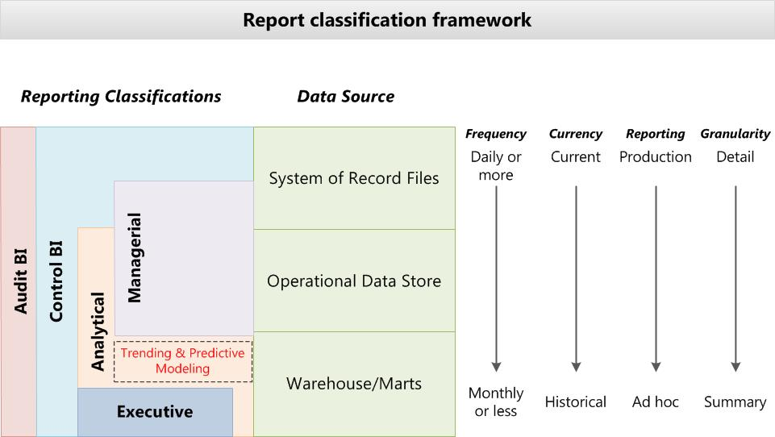

Figure : Report classification framework

#### Operational Business Intelligence

Operational BI gains insight into the day-to-day operations of the business. It focuses heavily on business transactions at the detail level to provide additional tactical insight into the “pulse” of the business.

An Operational BI solution includes the following characteristics:

* It utilizes real-time or near-time data, rather than historical data.
* It is viewed or monitored by the business on a continuous basis, rather than periodically over weeks or months.
* It is relatively structured and rigid in output that it usually produces or generates through automated, production mechanisms.
* It often uses dashboards and scorecards, while allowing for interesting drill-down information generally limited to the operational data that is the focus of the operational data set.
* It usually handles a relatively small dataset in high volumes that is sourced or processed against the production system of record data stores. This approach requires awareness of performance issues and system tuning to avoid impacts on the business and the transactions that are being processed. In situations in which real-time data is not critical, an Operational BI solution can take advantage of an operational data store as its source to avoid any impact on the production system of the record data stores.

#### Strategic Business Intelligence

Strategic BI targets executive level business leaders, whereas operational reporting is tactically useful throughout an enterprise. Strategic BI helps executives deal with adjusting and adapting broader plans and strategies.

A Strategic BI solution has the following characteristics:

* It utilizes both current and historic data.
* It refreshes less frequently than operational data.
* It focuses more on summarized data than detail data.
* It provides ad hoc manipulation and drill-down capabilities.
* It utilizes more graphical presentation of data than an Operational BI solution.

Though many organizations start with operational BI objectives, the objectives often rapidly grow to meet the increasing demands of strategic business analysis. The following sections summarize broad characteristics of BI components that address operational and strategic functional requirements for organizations.

## Business Value Proposition

Data is available throughout the business world today, but not all organizations know how to stage, manipulate, analyze, and access data in a way that produces knowledge.

The value of a BI solution is to improve the ability of an enterprise to make business decisions. Though BI solutions use IT metrics to demonstrate business KPIs, IT metrics themselves do not drive value propositions for BI solutions. Business results related to using certain capabilities of the solution should be measured and correlated with the development costs of those capabilities. For example, the following features of BI solutions are part of the business value proposition:

* Accuracy of the data.
* Availability of high quality information.
* Ease of obtaining the data using BI tools and interface.
* Ability to obtain the right information, at the right time, to answer the right questions.

To measure and quantify the value of BI for an organization requires that you develop a correlation between the improvements in business operations, and the cost of developing and providing the improved capabilities.

To develop this correlation, determine the total cost of ownership (TCO) for the business intelligence solution, including:

* The cost of building the data warehouse.
* The cost of information delivery.
* The cost of data gathering and management.
* The cost of associated infrastructures, software, tools and support resources.

Beyond the basic costs to build the solution and the on-going infrastructure costs, you also need to consider and amortize:

* On-going training and staff development.
* On-going support costs.

The value of a BI solution to an enterprise is in its ability to provide better decision making capability, and to meet organizational and customer demands for information. To help determine the value of the BI solution to the customer, answer the following questions:

* Is information available to people and systems when it is needed to make critical decisions?
* Is the staff trained to use the information that is delivered, and the tools that are available to analyze the data?
* Does the organization utilize information to work smarter and make better decisions?
* Can you quantify the effect of the delivered data on revenue or on the cost of delivery?
* Can the right people access the right data at the right time with ease and security?

Key performance indicators (KPI) can also help determine ROI if they can be measured. These indicators measure success within three business categories:

* **Organizational**. Measures the impact of a BI solution to support the business strategies for an organization.
* **People**. Measures the impact of a BI solution on people who participate in business processes and use information to perform processes. A common initial goal for a BI solution is to reduce the number of people who are required to gather, manage, and support BI information. For people who use BI information, metrics are established to measure self-sufficiency and ease-of-use.
* **Operations**. Measures the impact of a business intelligence solution on business operations, such as cost, speed of delivery, security, and capacity.

The following table lists KPIs that help determine ROI.

**Table 5. Common Measures of Success for New BI Solutions**

|  |  |  |  |
| --- | --- | --- | --- |
|  | Organizational (Enterprise) | People (Individuals) | Operations (System) |
| **Audience** | **Improve**:  Cross-functional data use | **Maximize**:  Usage of BI data  Usage of BI capabilities  Usage of BI methods | **Maximize**:  Support staff required |
| **Cost** | **Reduce**:  Financial write-offs  **Improve**:  Risk portfolio | **Reduce:**  Non-system help desk calls | **Reduce**:  Human resource cost  Infrastructure cost  Change management cost  Production support cost  Operations cost |
| **Time** | **Reduce**:  Overall process duration |  | **Meet SLA for**:  End-to-end refresh of data  **Reduce**:  End-of-day processing |
| **Quality** | **Improve**:  Customer satisfaction |  | **Meet SLA for**:  Root cause analysis  Help desk ticket resolution |
| **Security** | **Improve**:  Security governance | **Improve**:  Definition of user roles | **Reduce**:  Security breaches |
| **Conformance** | **Improve**:  Regulatory compliance |  | **Comply with**:  Security reporting audits |

You can include many of the KPIs, even those that are non-quantifiable and not included in the ROI, in the analysis of the business value proposition described at the beginning of the “Requirements” section of this document. These KPIs are often identified as the “observable” measures of how business values align to strategy, goals, and objectives.

## Drivers

An effective BI solution possesses attributes of quality information yet adapts to changing business conditions. The guiding principles of these solutions are to:

* Align with organizational strategy and operational business processes
* Provide decision support based on data and flexibility
* Consistently produce quality data

A high-quality BI solution produces improved key metrics that support informed decision making, identify inefficiencies, and provide guidance for resource planning.

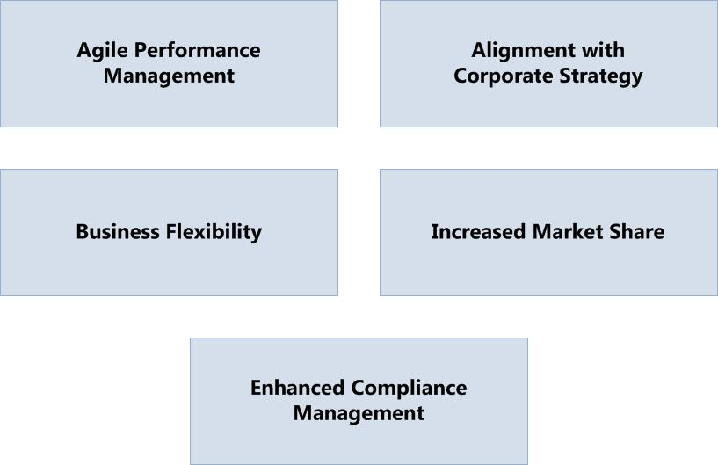

Figure . Business drivers that influence BI solutions

A BI solution provides a framework for collecting and managing operational and strategic data, and for analyzing and presenting the information that the enterprise derives from the collected data.

According to Deloitte, the primary business drivers for improving the capture, access, and analysis of tactical business data include the following:[1]

* New technologies enable real-time access to information, as well as more insightful presentation and analysis infrastructures, and opportunities to work collaboratively.
* Regulatory mandates and industry compliance bodies, such as the Financial Industry Regulatory Authority (FINRA) in the U.S., require enterprises to disclose increasing amounts of information about business operations and products.
* The ability to collect, produce, and share customer, investor, partner, and operational data requires implementing risk management and security practices to monitor and protect information.

Strategic drivers for BI can include:

* Loss of market share or revenue
* Lack of understanding of customer demographics and tendencies
* Geographical disparity in product sales or services
* Unfavorable ratings from external quality or competitive research firms
* Reduced customer satisfaction
* Lack of new or enhanced product market analysis
* Analysis of competitors

A BI solution uses common BI framework and design principles to address the drivers of an organization. The ways in which these drivers are addressed can make or break a successful BI solution. The common framework and design principles help to improve the success of the solution, but the requirements of the organization will determine the business value success of the solution.

Since any BI solution is “sold” on its business value and every customer’s business value is unique, it is critical to establish and agree up front on the metrics and measures that will determine the returned business value. The drivers to consider are:

* What are the business values that were identified as justification for the BI project?
* How will the BI solution deliver on those values?
* How will the delivered value realization be measured and over what time frame?

Understanding what the customer requires and how the customer values it is critical for executive adoption and sponsorship of BI initiatives. This is especially true when the requirements and values are strategic or have large financial impacts.

Enterprise BI solutions have many common drivers, such as the following:

* **Interactive reports**. Provides hierarchical, filtered views of business metrics and trends.
* **User collaboration**. Enables users to interact with each other to share findings and ideas.
* **Business performance monitoring and analysis**. Provides tools to visualize key performance indicators, categorize data, identify business trends, project future performance, and design reports to analyze business performance.
* **Business planning**. Provides statistical evidence from internal and external sources, as well as analytical tools, to support informed tactical decisions to improve business performance. Uses secure methods to provide information to suppliers and partners to support collaboration.
* **Heterogeneous device support**. Supports a variety of connected and disconnected devices, and can scale features if necessary.
* **Dashboard customization and self-service**. Allows users to customize data views and create graphical components, according to their roles.
* **Language standards**. Support language standards for the enterprise.

These drivers are common to the BI Framework and customers should address them in every BI solution. In addition to these common requirements, each customer has policy drivers that impact how to build the solution. These policy drivers include:

* Sourcing data in terms of single source/multiple source, and system of record versus secondary sources, as well as percentage of data population required.
* Specific source data set to use.
* Age of the data to use.
* Cycle interval when the data is accumulated or refreshed.
* Accuracy of the data (data quality).
* Retention and archive requirements of both the acquired data and all BI generated data.

Retention and archive requirements are especially important for strategic BI solutions with “drill-down” capabilities that need to retain a significant amount of historical data, which can impact performance if left unchecked.

For example, a strategic BI solution that may ultimately store five or more years of summary data may retain the drill-down capability for the current and past year, but archive and disable drill-down data for the remaining years. Understanding the customer's drivers around the importance of history, especially detailed history, will result in solutions that are optimized for performance without sacrificing benefits.

# Appendix B: Functional and Nonfunctional Requirements for BI solutions

This appendix provides detailed functional and nonfunctional requirements of business intelligence (BI) solutions, as well as a traceability matrix that maps requirements to the aligned layers of the BI Business Conceptual Model.

## Details of Common Functional Requirements

Functional requirements include the following categories:

* Interactive Reports and Data Navigation
* User Collaboration
* Business Performance Monitoring
* Business Performance Analysis
* Business Planning
* Heterogeneous Device Support
* Dashboard Customization and Self-Service
* Multilanguage

The following table lists examples of functional requirements that represent some of the architectural considerations. In conversations with customers, you can use the following table to check-off applicable requirements, amend with additional requirements, identify the sources for each requirement, and use the ID numbers to track requirements during implementation.

Table . Information Functional Requirements

| **Check if applies** | **Category** | **Requirement** | **Source** | **ID** |
| --- | --- | --- | --- | --- |
|  | Interactive Reports and Data Navigation | BI reporting will be available on-demand via a web portal. |  | FR01 |
|  | Interactive Reports and Data Navigation | Reporting are available as grids, maps, charts, and hierarchical decomposition trees. |  | FR02 |
|  | Interactive Reports and Data Navigation | Menus support tabs and breadcrumbs to enable access. |  | FR03 |
|  | Interactive Reports and Data Navigation | Reporting support pagination and tabbed results sets. |  | FR04 |
|  | Interactive Reports and Data Navigation | Reporting has ability to search for data and reports. |  | FR05 |
|  | Interactive Reports and Data Navigation | Reporting has the ability to export information to Microsoft Excel. |  | FR06 |
|  | Interactive Reports and Data Navigation | Users have the ability to build new reports and save them for re-use. |  | FR07 |
|  | Interactive Reports and Data Navigation | The BI environment has a full development environment for developing new reporting. |  | FR08 |
|  | User Collaboration | Reports can be added to a report catalogue and are accessible to other report users. |  | FR09 |
|  | Interactive Reports and Data Navigation | Reports can be rendered in multiple formats including Excel, XML, Word and PDF. |  | FR10 |
|  | Interactive Reports and Data Navigation | Report manager has the capability to apply style sheets to alter the report layout and presentation. |  | FR11 |
|  | Interactive Reports and Data Navigation | Reports can be linked together to create a hierarchy of associated reports. |  | FR12 |
|  | Interactive Reports and Data Navigation | Frequently used reports can be cached to improve system performance. |  | FR13 |
|  | Interactive Reports and Data Navigation | Reports can be either ad-hoc or scheduled to run at specific times and subsequently delivered to defined list of recipients. |  | FR14 |
|  | Interactive Reports and Data Navigation | Reports can be localized. |  | FR15 |
|  | Interactive Reports and Data Navigation | Access to reports is controlled by Active Directory authentication. |  | FR16 |
|  | Business Performance Analysis | System tools are provided to support the design and creation of cubes. |  | FR17 |
|  | Dashboard Customization and Self-Service | The solution provides tools that support the design and deployment of dashboards and scorecards. |  | FR18 |
|  | Interactive Reports and Data Navigation | Query editor is available to build, execute, and test reporting scripts. |  | FR19 |
|  | Interactive Reports and Data Navigation | The solution allows users to navigate to the dashboard from the high-level view to the detail and report view. |  | FR20 |
|  | Interactive Reports and Data Navigation | The solution provides a summary view. This view aggregates the business metrics, and is usually presented in a scorecard format. |  | FR21 |
|  | Interactive Reports and Data Navigation | The solution provides a second-tier view. This view might show trends, a breakdown of the summary view, or a closer look at a specific metric. |  | FR22 |
|  | Interactive Reports and Data Navigation | The solution provides a raw data view. This view is often just the tabular format data you see in reports. |  | FR23 |
|  | Interactive Reports and Data Navigation | The solution allows users to drill down from one view into another view and filter the data. |  | FR24 |
|  | Interactive Reports and Data Navigation | The solution provides alerts based on business rules. |  | FR25 |
|  | Interactive Reports and Data Navigation | The solution provides messages based on business rules. |  | FR26 |
|  | Interactive Reports and Data Navigation | The solution provides both preset and ad-hoc reporting. |  | FR27 |
|  | User Collaboration | The solution allows users to interact with each other from inside the dashboard so that they can understand and share findings. |  | FR28 |
|  | User Collaboration | The solution allows users to share comments and add annotations to dashboard snapshots. |  | FR29 |
|  | User Collaboration | The solution allows users to subscribe or unsubscribe to alerts that notify them when dashboards and reports are refreshed. |  | FR30 |
|  | User Collaboration | The solution allows users to set alarms for when key performance indicators fall out of a specific range. |  | FR31 |
|  | Business Performance Analysis | The solution helps users analyze current business performance and estimate future performance based on predictions that the dashboard provides. |  | FR32 |
|  | Business Performance Monitoring | The solution allows users to visualize key performance indicators, categorize data, and render reports designed for monitoring performance. |  | FR33 |
|  | Business Performance Monitoring | The solution is user friendly and flexible to enable users to record and report performance or contextual information at multiple levels within the organization. As strategic BI is introduced, the solution will link to organizational strategy and drivers to identify employee contributions (“golden thread”) and by extension, contribute to improving organization performance and efficiencies. |  | FR34 |
|  | Business Performance Analysis | The solution allows users to isolate a specific business performance trend or metric, find the possible causes for it, and determine how and why it occurred through the dashboard application. |  | FR35 |
|  | Business Performance Analysis | The solution allows users to access current and projected performance metrics and create a series of what-if scenarios to assist them in improving business performance. |  | FR36 |
|  | Business Performance Analysis | The solution allows history and snapshots to be recreated over time. |  | FR37 |
|  | Business Planning | The solution assists the decision making process by providing statistical evidence that supports informed tactical steps to improve business performance. |  | FR38 |
|  | Business Planning | The solution allows the user to integrate external data source used by a dashboard. |  | FR39 |
|  | Business Planning | The solution allows, based on the business rules for history, the user to overlay trends with past data, and create multiple predictions based on current data. |  | FR40 |
|  | Business Planning | The solution allows users to perform real-time collaboration with internal and external team members, as well as publish information to suppliers and partners using a secure, efficient and controlled method. |  | FR41 |
|  | Heterogeneous Device Support | The solution supports different devices. Different deployment scenarios might require a different range of capabilities on different devices. |  | FR42 |
|  | Heterogeneous Device Support | The solution provides a lightweight version of the dashboard that a user can view on a mobile device or less powerful desktop version running on a PC. |  | FR43 |
|  | Heterogeneous Device Support | The solution supports remote access for devices that are not on the local network. |  | FR44 |
|  | Heterogeneous Device Support | The solution considers supporting the disconnected scenarios that often occur with mobile or roaming clients. |  | FR45 |
|  | Dashboard Customization and Self-Service | The solution allows users to customize the dashboard and create their own dashboard view, according to their roles. |  | FR46 |
|  | Dashboard Customization and Self-Service | The solution allows users with basic technical skills to define graphical components that consume data from reports or data sources. |  | FR47 |

## Details of Common Nonfunctional Requirements

Nonfunctional requirements include the following categories:

* Operational
* System
* Metadata / Data Dictionary
* Security
* Performance
* Reliability
* Availability

The nonfunctional requirements listed in the following two tables are components of the BI Service Delivery view and the BI Technology view.

The requirements listed represent common architectural considerations. In conversations with customers, you can use the following table to check-off applicable requirements, amend with additional requirements, identify the sources for each requirement, and use the ID numbers to track requirements during implementation.

Table . Operational Nonfunctional Requirements

| **Check if applies** | **Category** | **Requirement** | **Source** | **ID** |
| --- | --- | --- | --- | --- |
|  | Business Performance Monitoring | Tools are available to monitor performance and resource utilization. |  |  |
|  | Business Performance Monitoring | Monitoring and reporting of extract-transform-load (ETL) processes is provided as part of the standard system. |  |  |
|  | Business Performance Monitoring | Auditing and logging of events and errors is part of the standard system. |  |  |
|  | Operational | Centralized policy management – authentication, security, applications – is present. |  |  |
|  | Operational | BI software updates are automatically patched and updated. |  |  |
|  | Operational | Centralized health monitoring of distributed data warehouse instances is available. |  |  |
|  | Operational | Installation and recovery of all desktop BI tools is automated. |  |  |
|  | System | Availability 24 hours a day, seven days a week at 99.99 percent. |  |  |
|  | System | Policy updates are staged and tested prior to deployment. |  |  |
|  | System | All account and loan data is stored centrally. |  |  |
|  | Performance | The solution should have good response time, throughput, and resource utilization levels. Good should be defined by a set of agreed-upon performance objectives that helps ensure system usability. |  |  |
|  | Performance | The solution is built to handle an increasing volume of report result data. The designers should know the upper limit of the system and allow for projected growth during the system's life cycle. |  |  |
|  | Performance | The solution provides rapid query response that summarizes a large volume of data to meet performance objectives. It efficiently processes result sets before returning them to upstream layers. |  |  |
|  | Reliability | The solution implements backup and restores strategies so that they can be restored easily without adversely affecting users or system operations staff. |  |  |
|  | Reliability | The solution builds in redundancy so that even if some part of the system fails, other parts take over and continue operations on the affected jobs. |  |  |
|  | Reliability | The solution is resilient if a hardware or software failure occurs. It can recover and restart from the point of failure. |  |  |
|  | Reliability | The solution provides correct information even when under heavy load or other adverse situations. |  |  |
|  | Availability | The solution is available according to the agreed service levels. |  |  |
|  | Availability | The solution gracefully degrades when parts of system are not available. The failure of a single nonessential component does not render the system inoperable. |  |  |
|  | Availability | The solution can deliver the presentation layer services to multiple user devices without major modification or duplication. |  |  |
|  | Availability | The solution supports the ability to purge or archive data. |  |  |
|  | Availability | The solution supports the ability to monitor usage and provide reporting to enable effective management of the business intelligence assets in the solution. |  |  |

Table . Technology Nonfunctional Requirements

| **Check if applies** | **Category** | **Requirement** | **Source** | **ID** |
| --- | --- | --- | --- | --- |
|  | Business Performance Analysis | The storage engine supports multiple formats, including:   * Multidimensional Online Analytical Processing (MOLAP) * Relational Online Analytical Processing (ROLAP) * Hybrid Online Analytical Processing(HOLAP) * Columnar |  |  |
|  | Business Performance Analysis | Data mining tools are available for mining relational and multi-dimensional tools. |  |  |
|  | Business Performance Analysis | Wizards and automated tools are available to support data mining. |  |  |
|  | Metadata / Data Dictionary | The solution provides for a centrally managed data dictionary that contains all the data attributes and entities named in a data dictionary. |  |  |
|  | Metadata / Data Dictionary | The solution provides the management of all metadata that defines and describes the characteristics of other data. Metadata is used to improve both business and technical understanding of data and data-related processes.  **Business metadata** includes the names and business definitions of subject areas, entities and attributes, attribute data types and other attribute properties, range descriptions, valid domain values and their definitions.  **Technical metadata** includes physical database table and column names, column properties, and the properties of other database objects, including how data is stored.  **Process metadata** defines and describes the characteristics of other system elements, such as processes, business rules, programs, jobs, and tools.  **Data stewardship metadata** is data about data stewards, stewardship processes and responsibility assignments. |  |  |
|  | Metadata / Data Dictionary | The solution provides a secure streamlined method for data reconciliation. |  |  |
|  | Operational | Help desk supports desktop deployment and support. |  |  |
|  | Operational | Automated install and recovery occurs for all desktop BI tools. |  |  |
|  | Operational | Centralized policy management – authentication, security, applications – is in place. |  |  |
|  | Operational | BI software updates are automatically applied and updated. |  |  |
|  | Operational | Centralized health monitoring of distributed data warehouse instances is available. |  |  |
|  | Operational | Data profiling tools are available to fix data quality issues prior to loading data into the warehouse. |  |  |
|  | Operational | The system provides an Extract, Transform and Load subsystem that facilitates the data warehouse loading. |  |  |
|  | Operational | Data warehousing maintenance supports both push and pull mode processing |  |  |
|  | Operational | Help desk supports desktop deployment and support. |  |  |
|  | Security | Federated search access is limited to a defined list of users. |  |  |
|  | Security | Remote access to BI data is authenticated and authorized. |  |  |
|  | Security | BI users must be authenticated. |  |  |
|  | Security | BI users must be authorized to access data. |  |  |
|  | Security | Secure remote network access is in place. |  |  |
|  | Security | Common user ID and password for internal and mobile is required. |  |  |
|  | Security | The solution authenticates all callers. |  |  |
|  | Security | The solution supports integration with existing access management mechanisms for authentication and authorization. |  |  |
|  | Security | The solution validates user access to resources and user ability to perform specific operations. The solution “filters” output based on access privileges allowing restricted views rather than no access at all. |  |  |
|  | Security | The solution prevents malicious users from using the application to access solution-level resources. |  |  |
|  | Security | The solution helps ensure that sensitive data remains secure while in storage and when transmitted over the network. |  |  |
|  | Security | The solution helps ensure that sensitive configuration information and sensitive persisted data are encrypted. |  |  |
|  | Security | The solution must secure the administration interfaces and configuration stores. |  |  |
|  | Security | To address parameter manipulation vulnerabilities, the solution validates all input. |  |  |
|  | Reliability | The solution implements backup and restore strategies so that it can be restored easily without adversely affecting users or system operations staff. |  |  |
|  | Reliability | The solution builds in redundancy so that even if some part of the system fails, other parts take over and continue operations on the affected jobs. |  |  |
|  | Reliability | The solution is resilient if a hardware or software failure occurs. It should be able to recover and restart from the point of failure. |  |  |
|  | Reliability | The solution provides correct information even when under heavy load or other adverse situations. |  |  |
|  | Availability | The solution is available according to the agreed service levels. |  |  |
|  | Availability | The solution gracefully degrades when parts of system are not available. The failure of a single non-essential component does not render the system inoperable. |  |  |
|  | Availability | The solution delivers the presentation layer services to multiple user devices without major modification or duplication. |  |  |
|  | Availability | The solution supports the ability to purge or archive data. |  |  |
|  | Availability | The solution supports the ability to monitor usage and provide reporting to enable effective management of the business intelligence assets in the solution. |  |  |
|  | System | Availability 24 hours a day, seven days a week at 99.99 percent. |  |  |
|  | System | Policy updates are staged and tested prior to deployment. |  |  |
|  | System | All account and loan data is stored centrally. |  |  |
|  | Performance | The solution should have good response time, throughput, and resource utilization levels. Good should be defined by a set of agreed-upon performance objectives that helps ensure system usability. |  |  |
|  | Performance | The solution is built to handle an increasing volume of report result data. The designers should know the upper limit of the system, and allow for projected growth during the system's life cycle. |  |  |
|  | Performance | The solution provides rapid query responses that summarize a large volume of data to meet performance objectives. It efficiently processes result sets before returning them to upstream layers. |  |  |

## Aligning Requirements to the BI Business Conceptual Model

Use a “Feature Traceability Matrix,” such as the example below, to map the functional requirements to the following aligned layers of the BI Business Conceptual Model:

* Client subsystem
* Presentation subsystem
* Reporting subsystem
* Analysis subsystem
* Data subsystem

The following table indicates just a few of the possible requirements that you can map to various subsystems.

Table . Mapping Requirements to Layers of the BI Business Conceptual Model

| **Layer** | **Component** | **Requirements Map** |
| --- | --- | --- |
| Client Subsystem | Web Client |  |
| Rich Client |  |
| Office Client |  |
| Rich Internet Application |  |
| Mobile Client |  |
| Presentation Subsystem | Site Subsystem |  |
| Page Layout Subsystem |  |
| UI Control Manager |  |
| Print Manager |  |
| Alert Manager |  |
| Presentation Format Manager |  |
| Reporting Subsystem | Report Authoring Tool |  |
| Report Data Manager |  |
| Report Monitoring Subsystem |  |
| Report Rendering Subsystem |  |
| Report Catalog Manager |  |
| Delivery Manager |  |
| Report Subscription Subsystem |  |
| Report Management Subsystem |  |
| Analysis Subsystem | OLAP Authoring Tool |  |
| Data Mining Subsystem |  |
| Cube System |  |
| Analysis Storage Subsystem |  |
| Analysis Management Subsystem |  |
| Data Subsystem | Extract Subsystem |  |
| Load Subsystem |  |
| Transformation Subsystem |  |
| ETL Management |  |

# Appendix C: Customizable BI Reference Model

The BIRA conceptual model focuses on the following capabilities:

* BI Analytics
* BI Reporting
* BI Data Source
* Information Management
* Information Infrastructure
* Information Repository

See Appendix C for a customizable BI Reference Model describing capabilities and sub-capabilities.

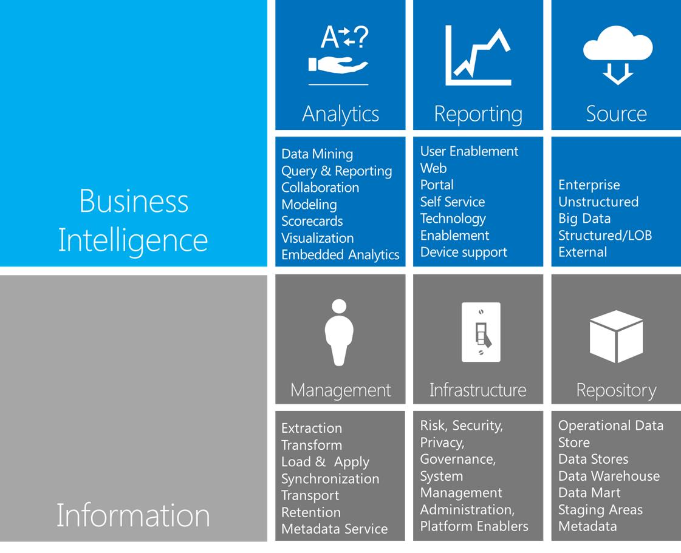

BI-related capabilities of a BI solution are:

| **Capability** | **Sub-capability** | Description |
| --- | --- | --- |
| **Analytics** | Data Mining | <placeholder: examining operational or strategic data captured or acquired by an enterprise> |
| Query & Reporting | BI solutions report information to users in a variety of ways depending on the nature of the BI and the activities of the end users.   * Operational BI reports are generally presented on dashboards, in output reports, and limited scope ad hoc reporting. Operational BI Reporting solutions often generate alerts and messages based on thresholds and triggers. * Strategic BI reports generally use interactive dashboards and scorecards. These tools use graphical representations that allow users to quickly and intuitively identify areas of concern or focus.   Reports support preset, ad-hoc, subscription (pull), personalization (for example, push, user group, location, and role) and data mining. Self-service reporting takes on more importance as an organization moves into strategic and predictive business analysis.  Reports may also include alerts: messages or signals that a BI solution sends out after noting specific operational thresholds, levels, or other indicators. Alerts are often sent to people via email or phone messages. Alerts trigger actions based on conditions or thresholds that are detected by the operational BI system. Alerts notify users that immediate action may be required, including specified users who might not monitor the dashboard of the BI system. |
| Collaboration | <placeholder: Performing work tasks together.> |
|  | Modeling | <placeholder: creating domain-specific strategies for applying data and producing insight. |
| Dashboards | Dashboards share the following characteristics:   * Provide ways to navigate from high-level data views to the detail of business transactions. * Provide techniques to filter multiple information views simultaneously, and to filter information views independently. * Provide a graphical way to expose high-level important business metrics by using key performance indicators in a collocated fashion. * Use dashboard elements, including charts, grids, and indicators to provide graphical illustrations that are intuitive to users. * Enable users to interact with the dashboard by allowing them to select metrics and then drill down to details. * Enable users to make comparisons across business areas by using metrics and business reports. * React quickly to user input to display the requested information in a second or less.   Enable users to view different sources and types of information, such as multidimensional data, relational data, or files that use tabular data. |
| Scorecards | Scorecards appear on a dashboard to provide quick access to the key performance indicators (KPIs) that are needed most often, providing managers and business executives with a convenient and accurate historical summary of business results and success.  Scorecards share the following characteristics:   * Provide a set of numerical business metrics, commonly known as KPIs. These metrics have an associated range of satisfactory or unsatisfactory values to indicate normal, troubled, or critical business performance. * Display a collection of visual KPIs when the scorecard is displayed on a dashboard. * Use current data to maintain and visually represent scorecards on the dashboard.   Provide visual indicators to illustrate the business trends as they relate to a set of predetermined goals. |
| Visualization | <placeholder: Using sight as a means of accessing and interacting with data and analytics, and organizing and presenting content in a visually consumable format.> |
| Embedded Analytics | <placeholder: Analysis of sets of data using sophisticated statistical and data mining techniques for discovering why something happened, and forecasting techniques to predict what is likely to happen in the future.  “Sensemaking” is an analysis cycle that uses continuous feedback and defines interdependent relationships to create a context that provides information about data and supports the analysis of the data. The sensemaking process maps business objectives to data in real-time, drawing out knowledge that may form the basis for immediate action, such as modifying product prices in real-time.> |
| **Reporting** | User Enablement | <placeholder: The capability for users to define the components and delivery attributes of data and analytics> |
| Web | <placeholder: The capability for accessing business intelligence and collaboration tools using the World Wide Web protocols of the Internet> |
| Portal | <placeholder: The user interface accessed on the web that provides access to data and analytics.> |
| Self-Service | Predefined and packaged units of BI components designed for self-service users that are less experienced than developers or power users. The easy-to-use components can be customized for specific business problems and personalized for specific users. |
| Technology | <placeholder> |
| Enablement | <placeholder> |
| Device Support | <placeholder: The capability to support a variety of user devices, such as tablets, phones, and other portable devices, while maintaining control over data and analytics> |
| **Data Source** | Enterprise | <placeholder> |
| Unstructured | <placeholder: Data, such as streaming video, that cannot be organized in traditional database formats.> |
| Big Data | Very large data sets that exceed the capacity of typical database tools to acquire, store, manage, and utilize the data. |
| Structured / LOB | <Placeholder: Data, such as business transactions, that is organized using line-of-business applications using schemas or data models.> |
| External | <placeholder: Data acquired by a business for operational, strategic, or analytical purposes.> |

Information-related capabilities of a BI solution are:

| **Capability** | **Sub-capability** | Description |
| --- | --- | --- |
| **Management** | Extraction | Data transfer from various LOB and external sources into the staging database (or database tables) that the data warehouse consumes. |
| Transform |
| Load and Apply |
| Synchronization | <placeholder: The capability of keeping stored data synchronized in multiple locations>. |
| Transport | <placeholder: The movement of data from one location to another requires adherence to protocols and governance to protect the data> |
| Retention | <placeholder: Retention indicates a policy-driven practice for specifying the amount of time that data is available, and the process for purging or backing up business data> |
| Metadata Service | <placeholder> |
| **Infrastructure** | Risk: Security, Privacy, Governance | Security: <placeholder>  Privacy: <placeholder>  Governance: Governance activities for BI solutions are organized into several layers that interact to meet business objectives:   * **Business domain governance**. Sets the strategic direction and organizational alignment for delivering services within a governance framework * **Portfolio governance**. Focuses on operational strategies that have near term priorities and ROI * **Technology governance**. Monitors and evaluates technical advances and direction, and creates strategic alignment and synergy among technological areas and products * **Project governance**. Defines service delivery and schedules, identifying priorities, and managing interdependencies among projects.   **SLA governance**. Defines service performance and availability, conducts capacity analysis, and creates plans to meet capacity and availability targets, as defined in the SLA |
| System Management | <placeholder> |
| System Administration | <placeholder> |
| Platform Enablers | <placeholder> |
| **Repository** | Operational Data Store | <placeholder: a repository that contains data drawn from multiple sources> |
|  | Data Store | <placeholder: a repository of data organized in a structured fashion> |
|  | Data Warehouse | The core data store unit for strategic BI solutions, although not all solutions use them. The data warehouse is a subject-oriented, integrated, time-variant, non-volatile collection of data that is used to support a strategic decision-making process for the enterprise. The purpose of the data warehouse is to provide a single managed, historical data repository for the enterprise. |
|  | Data Mart | The analytical databases that serve the operational reporting needs for specific business units, or all business units. Data marts contain dimensionally organized facts about a segment of the business. Data marts are generally associated with business processes, not departments/business units. |
|  | Staging Areas | <placeholder: Temporary locations for data being moved or transformed.> |
|  | Metadata | Identifies the characteristics of the data (such as business identity and rules of use). Metadata is critical when determining the use and meaning of the data held in the data warehouse. A key goal and success metric for metadata management is to effectively enable business intelligence and analytic activities across an organization. |

# Appendix D: Value Propositions

## Information View Value Proposition

BI solutions are capable of delivering information and insight in a variety of ways, and offering a range of potential value propositions. The following table identifies the value propositions of BI capabilities, each of which targets different business goals.

Table : Information View Value Propositions

| **BI capability** | **Capability usage** | **User community** | **Value proposition** |
| --- | --- | --- | --- |
| Scorecards, dashboards, traditional reporting | Top-down management tools, often specific to the business unit, product line, or customer segment.  Obtaining status and results. Dispersal of operational data, metrics and KPIs.  Evaluate performance.  Data is periodic (after the fact). | Organization executives, line managers and supervisors.  Sales leaders. | Performance management that offers:  Strategic decisions by executive leadership.  Effective management of day-to-day company activities by line managers (short-term gains in operational efficiency).  Tactical changes in directions and/or unit leadership incentives. |
| OLAP, slice and dice, ad hoc requests/queries. real-time analytics | Deep analysis of the causes of good or bad performance (answering “why”).  Analysis of customer behavior. Structured data exploration. | Business and financial analysts | Tactical business strategy that offers:  Tactical changes in the direction or organization (long-term operational efficiencies) driven by business units.  Modifying existing product offerings (leading to increase in market share). |
| Advanced/  Predictive Analytics | Sophisticated statistical and data mining techniques for discovering why something happened.  Forecasting techniques to predict what is likely to happen in the future. | Business strategists, innovation officer, financial officer | Strategic business strategy that:  Changes strategic direction.  Creates new product offerings or target markets for existing/modified product offerings. |
| Data Warehouse | Acquiring, transforming and storing data relevant to the business. | IT business and data analysts | Improve data quality by providing the following:  Enriched data.  Insights unavailable from data belonging to that is accessible by the organization. |
| Non-SQL Data Warehouses | Columnar, tabular, raw (Hadoop) | IT business and data analysts | Big data and real-time analysis. |

# Appendix E: One-Page Introduction to Workshop for Customers

Are you challenged with getting started with the right data governance model?

If so, you’re not alone. Despite millions invested in data-centric applications and infrastructure, a lack of data governance is resulting in insufficient alignment between the business, the data management team, and IT at many organizations. The end result is lack of trusted data.

Let’s solve this problem together. Bring your issues and ideas to an interactive workshop hosted by data governance experts Informatica and Intricity.

Date: Wed, September 14, 2011

Time: 8:00 am to 12:00 pm

Location: Sheraton Reston

You’ll hear business practitioners and peers discuss...

• How to get started with the right data governance model

• Strategies for establishing the right roles and responsibilities within your organization

• How improving key business processes can drive better business outcomes

• How technology such as data quality, MDM, metadata management and ILM can support your data governance initiatives.

Together, we’ll develop a strategy for leveraging data governance to drive trusted data. We are inviting a close group of senior managers and data governance experts to this invitation-only event, so register today!

1. Kambil, Ajit; Conroy, Patrick; Ryan Alvanos. "The View from the Glass House." Deloitte Review, 2008. [www.deloitte.com/assets/Dcom-UnitedStates/Local Assets/Documents/US_deloittereview_View_From_The_Glass_House_feb08.pdf]